# Digi-Key 9X-Tend Modem Troubleshooting

## Modem System Summary

In order to establish a data link between the Khawk UAV system and the ground control station (GCS) in the Paparazzi GUI, the Digi-Key 9X-Tend modem was selected. One modem was installed in the aircraft body (air modem), while another modem was connected to a ground module that interfaces through an RS-232 link to the laptop (ground modem).

Although this set-up was successful in establishing a data link for the first Khawk aircraft, there was difficulty establishing a data link for the second Khawk. The steps followed to debug the modem connection are listed below.

## Troubleshooting Summary

1. First, the modem configuration was re-loaded.
   1. To ensure the correct configuration settings were uploaded to each modem, the modems used on the Khawk 1 were connected with an RS-232 cable to the Digi-Key modem program. The program extracted each modem’s configuration profile, and these configuration profiles were saved onto the computer.
   2. The proper configuration profiles were loaded onto the new modems.
   3. After uploading correct profiles, another attempt was made to establish a connection with the Khawk 2, but the modems still did not connect.
2. Next, the new air modem was mounted instead in the Khawk 1.
   1. On the Khawk 1, the LED lights on the ground modem base indicated that the modems were communicating with each other, but the GCS was unable to connect to the modem. Each time a flight session was established, a “no_md5_check” error occurred.
   2. Attempts were made to search the internet for solutions to the “no_md5_check” error. No similar problems could be found.
3. However, there was clearly a difference between the modem behavior on the Khawk 1 and the Khawk 2. The air modem mounted in the Khawk 1 could establish a data link, while the air modem in the Khawk 2 could not, even though the exact same configuration files were used.
   1. This indicated that a hardware issue was contributing to the problem. The oscilloscope was used to test the modem connector on the Khawk 2. This test indicated that the CTS pin (9) was not connected to power as it should be. Instead, pin 7 (SHDN) was connected to power. Because CTS was not connected to power, this air modem was not sending data to the ground modem, explaining the lack of a data link.
   2. The connector and the associated cable had already been mounted inside the aircraft, so the connector was carefully cut off, and a new connector was soldered on, connecting CTS correctly.
   3. After finishing the new connector, the modems successfully communicated with each other. However, the “no_md5_check” error still prevented the GCS from establishing a complete data link.
4. After further investigation, it became clear that the aforementioned error was the result of failing to re-upload the code to the paparazzi after **each** new build. After re-uploading the code after a new build, a successful data link was established, and the GCS was able to control the aircraft and monitor its movements.

## Modem Connection Guide

The drawings and tables below summarize the correct connections for interfacing the modem module with the paparazzi.

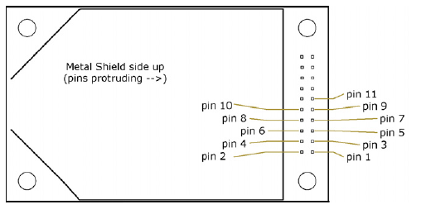

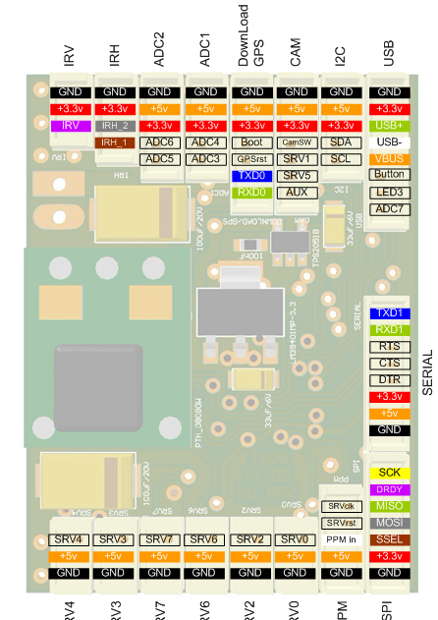

|  |  |
| --- | --- |
| **Modem Pin** | **Paparazzi Pin** |
| Pin 1- Ground | Pin 1- Ground |
| Pin 2- Power In | Pin 2- 5V Out |
| Pin 5- Data In | Pin 8- Data Out |
| Pin 6- Data Out | Pin 7- Data In |
| Pin 9- CTS | Pin 2- 5V Out |

The complete pinout information from Digi-Key has been included for reference.

